IDENTIFICATION OF VALID EMAIL ADDRESSES USING LEX

Aim
To write and implement a LEX program to identify and print all valid-looking email addresses from a given text file.

Algorithm
- Start the program.
- Create a text file named input.txt containing text and email addresses.
- Define a regular expression to recognize email address patterns.
- Open the input file using the fopen() function.
- Assign the opened file to yyin.
- Call yylex() to scan the input file.
- Print every matched email address using yytext.
- Close the input file.
- Stop the program.

Pseudocode
BEGIN
OPEN input.txt for reading

IF file cannot be opened
PRINT error message
STOP
END IF

SET yyin to input file
SCAN input using yylex()

FOR each match of the email regular expression
PRINT the matched text (yytext)
END FOR

CLOSE input file
END

Program
Save the following program as email.l.
%{
#include <stdio.h>
%}

%%
[A-Za-z0-9._%+-]+@[A-Za-z0-9.-]+\.[A-Za-z]{2,} {
printf("Valid email: %s\n", yytext);
}
.|\n ;
%%

int yywrap(void)
{
return 1;
}

int main(void)
{
FILE *fp = fopen("input.txt", "r");

if (fp == NULL)
{
printf("Error opening input.txt\n");
return 1;
}

yyin = fp;
yylex();

fclose(fp);
return 0;
}

Sample Input
Contact: abc@gmail.com
Mail: student123@yahoo.com
Invalid: student@com
Another: mani.raju@gmail.com

Output
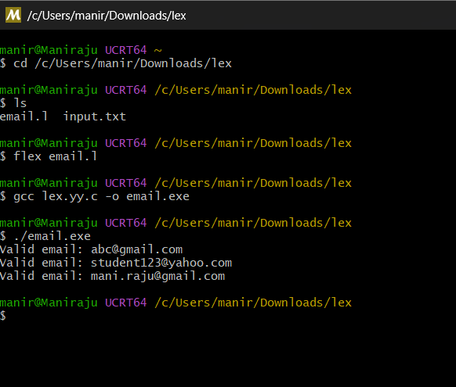

Result
Thus, the LEX program to identify and print valid-looking email addresses from the given text file was implemented successfully.

